1. What are the evidences of the Big Bang Theory?

Ans :

* Hubble’s law and the expansion of space : The most important and earliest evidence of the validity is expansion of the universe which is also stated by Hubble’s law. It states that v=HD (D is comoving distance, v is the recessional velocity and Ho  denotes the present-day Hubble constant).
* **Mixture of Element**s : As the Universe expanded and cooled down, some of the elements that we see today were created. The Big Bang theory predicts how much of each element should have been made in the early universe, and what we see in very distant galaxies and old stars is just right.
* **Microwave Background**: Very early in its history, the whole Universe was very hot. As it expanded, this heat left behind a "glow" that fills the entire Universe. The Big Bang theory not only predicts that this glow should exist, but that it should be visible as microwaves - part of the Electromagnetic Spectrum.

This is the Cosmic Microwave Background which has been accurately measured by orbiting detectors, and is very good evidence that the Big Bang theory is correct.

* The main alternative to the Big Bang theory of the Universe is called the Steady State theory. In this theory, the Universe does not change very much with time.

As light takes a long time to travel across the Universe, when we look at very distant galaxies, we are also looking back in time.

From this we can see that galaxies a long time ago were quite different from those today, showing that the Universe has changed. This fits better with the Big Bang theory than the Steady State theory giving an edge to it.

2. Why is the Big Bang Theory unique?

Ans : Scientists have shown, using theoretical calculations, that abundances of different elements could only have been made in a universe that began in a very hot, dense state, and then quickly cooled and expanded. This is exactly the kind of universe that the Big Bang theory predicts.

PTO

3. Calculate the semi-major axis of Venus using the Laws of Kepler [P=225 DAYS.].

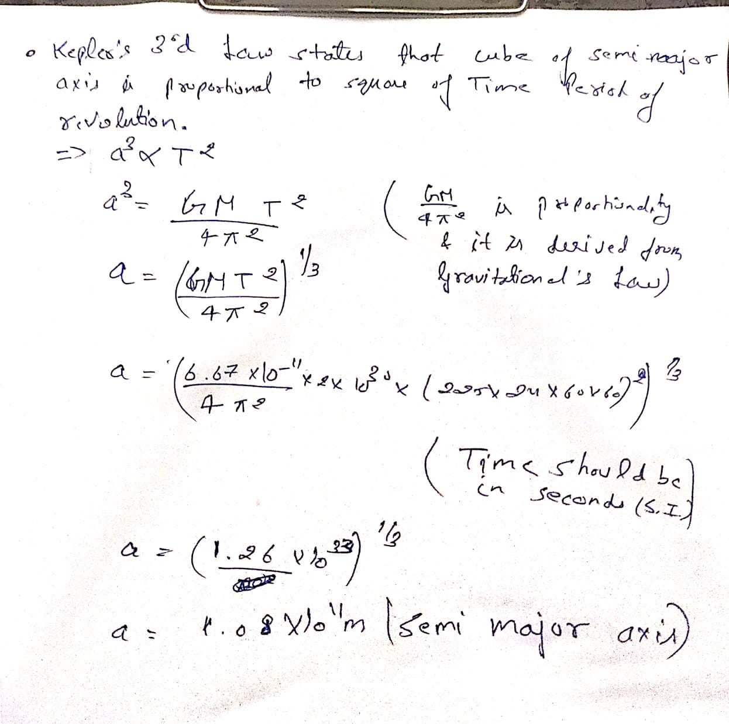Ans :

4. Is the universe Expanding or Contracting? Justify.

Ans : The universe is expanding. It was proved by American Astronomer Edwin Hubble in 1925. Hubble’s Law states that v=HD (D is comoving distance, v is the recessional velocity and Ho  denotes the present-day Hubble constant).

5. If you are in Mars, which of the following planet(s) will show phases?

(a) Mercury, Earth and Venus; (b) Mercury and Venus; (c) Venus; (d) Saturn, Uranus and Neptune.

Ans : a,b,c

6. Illustrate a drawing to show the Sun at the centre and the orbits of Venus, Earth, and Mars. Is the figure,  mark the location in Venus' orbit where a new phase of Venus can be seen from Earth. Also mark a sport with a different symbol to show where Venus will show a full phase. (use simple pencil on paper or any illustrating software (Illustrator, Corel, CAD etc.) [*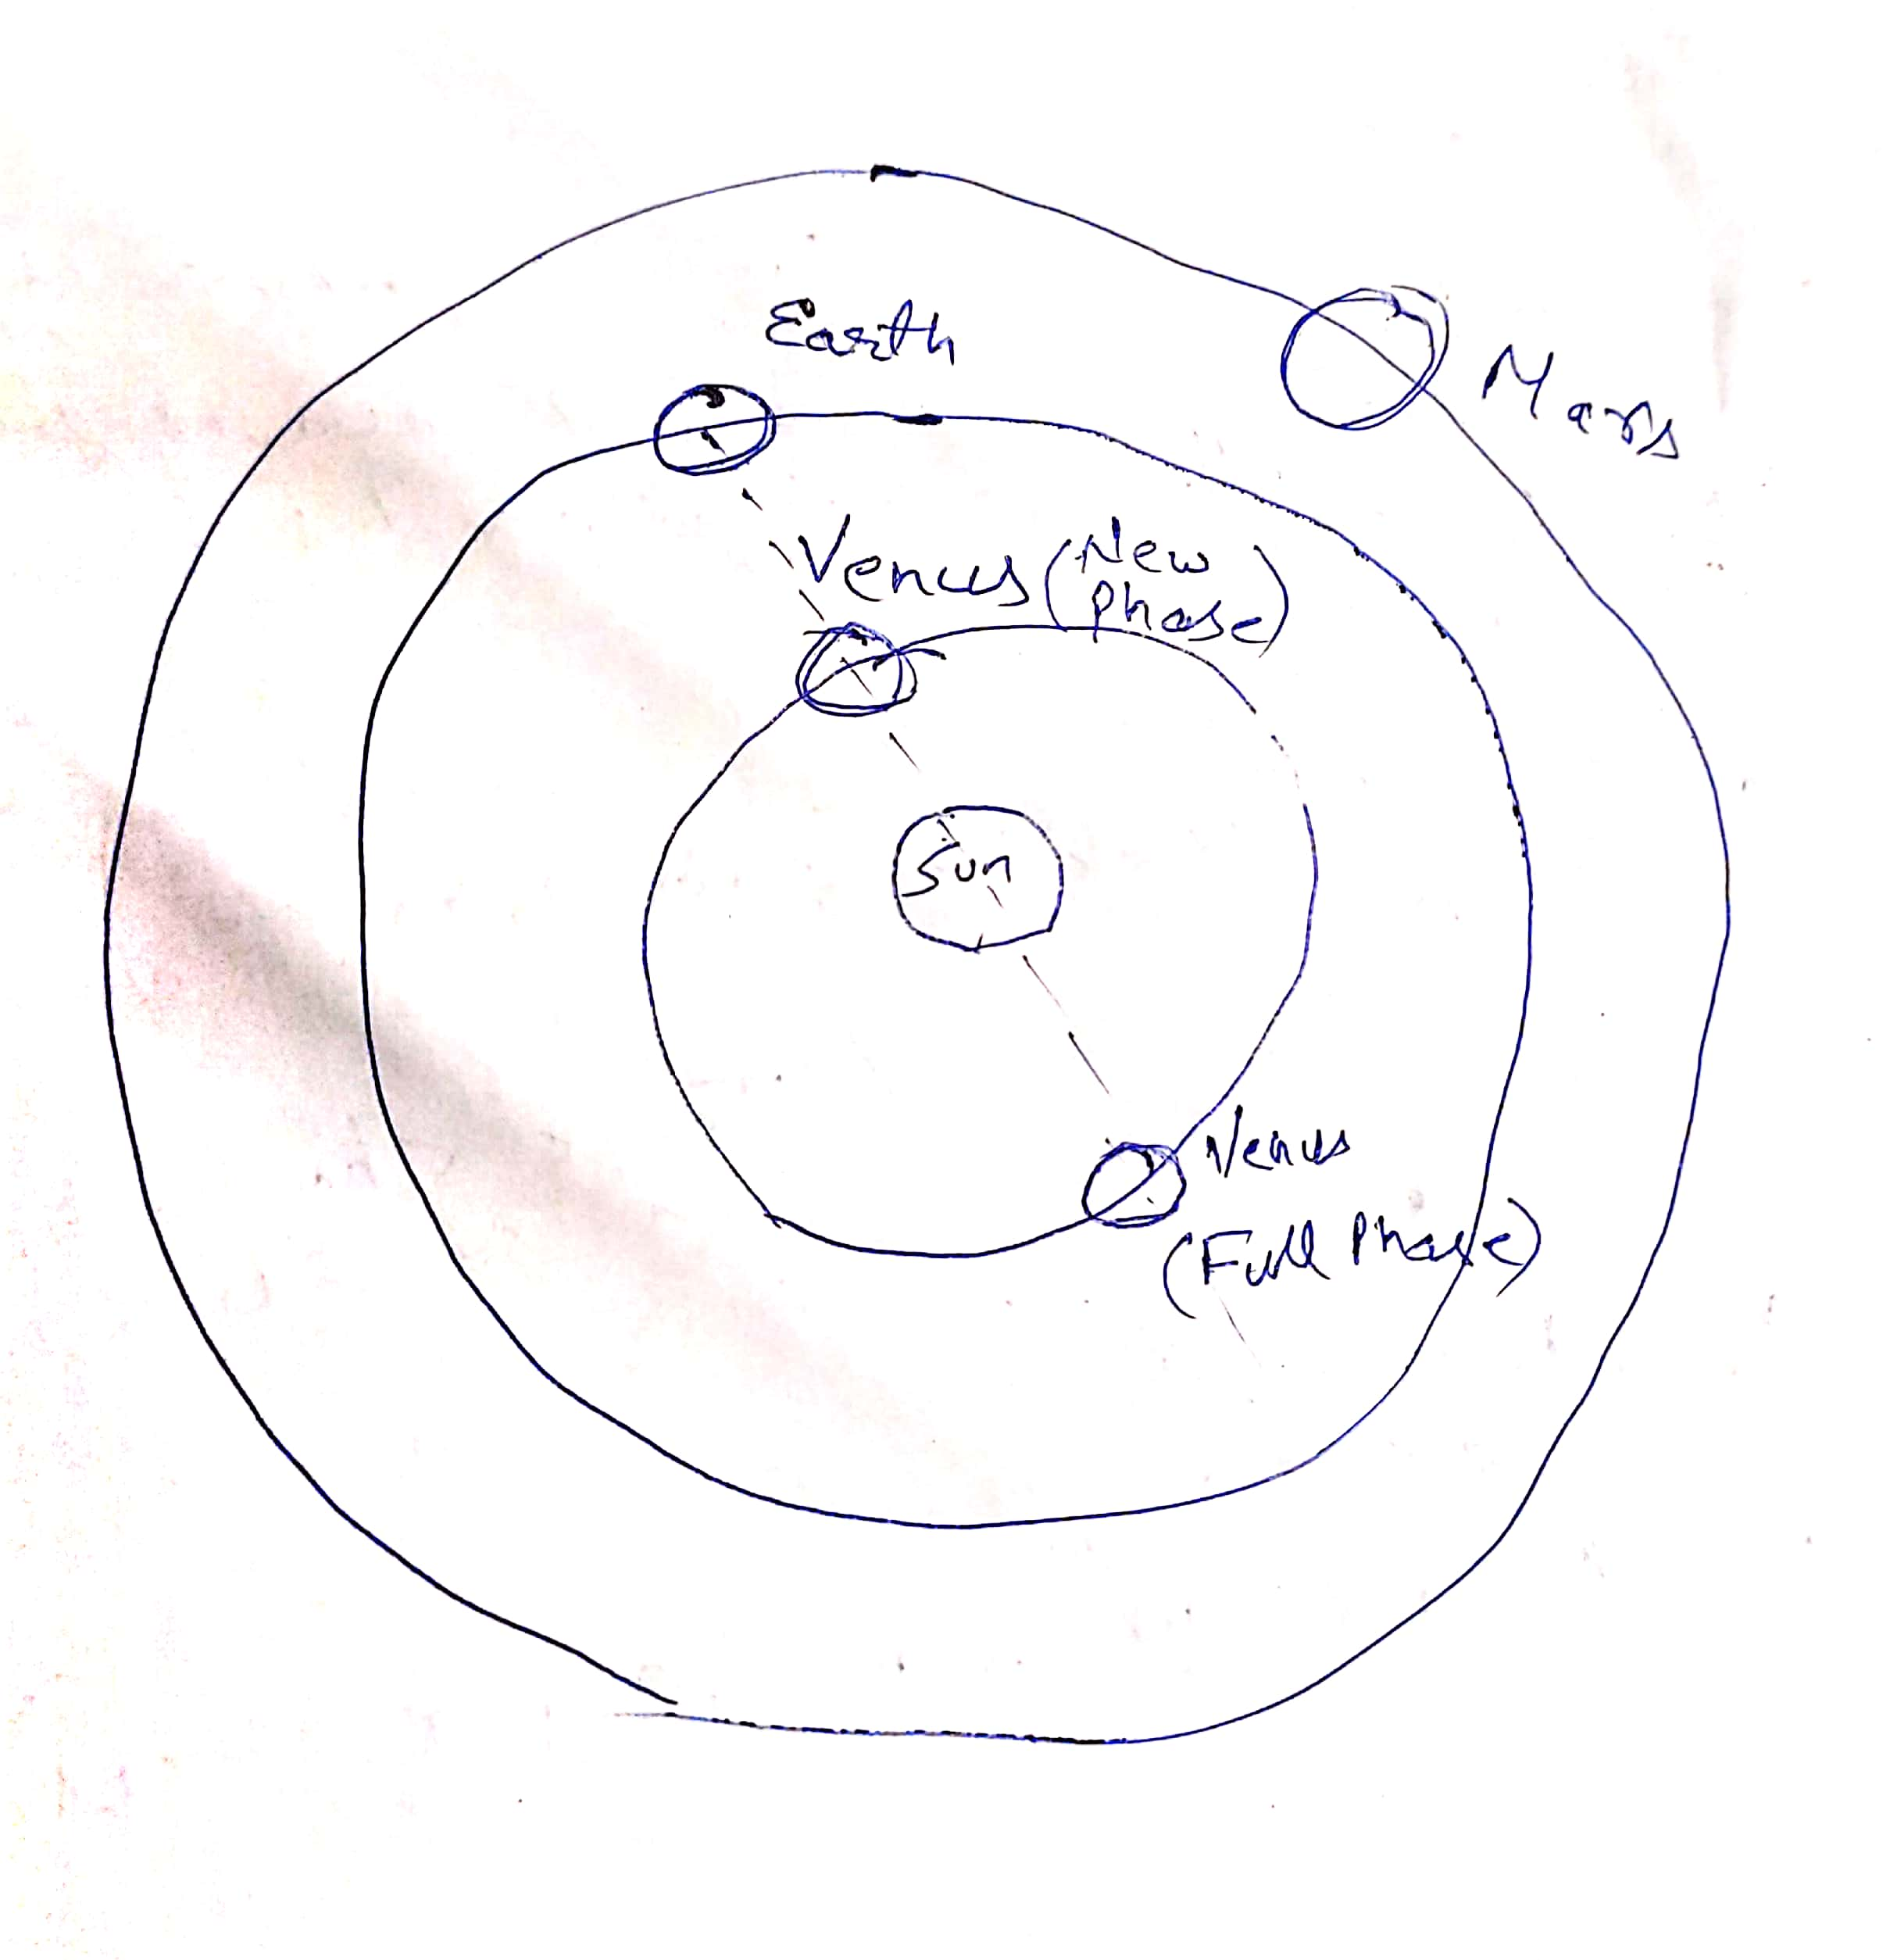clue: think the way of Galileo!]*

Ans :